Fin Well mentorship program

Color theme – BLUE+GREEN

Slide 1-

**Overview of Neurodiversity**:

* **Definition**: Neurodiversity refers to the variation in the human brain regarding sociability, learning, attention, mood, and other mental functions. It is an approach that advocates for viewing these differences as normal variations in the human population.
* **Examples**: Include neurodiverse conditions like Autism Spectrum Disorder, Attention Deficit Hyperactivity Disorder (ADHD), Dyslexia, and others. Each brings unique cognitive profiles that influence how individuals perceive and interact with the world.

**By Claudia Santos Aguirre, SISGI Group MSW Intern- problems faced**

* People with  neurodivergent conditions face many struggles finding employment.  Even once employed, many find it difficult to make connections and excel in the workplace. When agencies and managers do not [understand and provide support](https://time.com/charter/6309300/what-workplaces-misunderstand-about-neurodiversity/) in the workplace, neurodivergent employees may feel judged, excluded, or unvalued by the agency leading to low self esteem;  feeling uncomfortable and unsupported at work, and result in low productivity level or show low motivation.
* Individuals with neurodivergent conditions [often face discrimination and stigma](https://www.fairplaytalks.com/2022/09/16/six-out-of-10-neurodivergent-employees-misunderstood-experience-stigma-at-work-study-reveals/) as their symptoms often present as having limited interpersonal skills, communication/language skills, problems with eye contact, sensory problems, or “do not fit a company’s archetype”.  They face more obstacles in making it past preliminary job interviews. Many talented individuals do not have any other choice than look for work at a non-professional job market, and some become unemployed.
* Sadly, the [unemployment rate](https://youtu.be/GAehvcnFjmI?si=0ar9RKeojoFEYyXK) for neurodivergent individuals is as [high as 30% to 40%](https://imagine.jhu.edu/blog/2022/10/05/neurodivergence-at-a-glance/), compared to 10.1% for disabled persons in the US.
* Learning- Neurodivergent students face barriers when accessing higher education, including negative attitudes of faculty members, lack of assistive technology, traditional teaching methods and inflexible curricula. All these factors can compromise academic and social development, as well as participation.

Why diversity will benefit

* Diversity of all kinds contributes to creativity, innovation, and competitiveness the greater the diversity of your staff, the more unique ideas and perspectives you'll be able to bring to any given problem, and that include neurodiversity
* Neurodiverse individuals are an untapped pool of talent, and with 80% of Autistic people in Ireland being unemployed, there is a huge resource to help fill the skills shortage gap especially in the IT and Finance sectors
* Nerodiverse companies have been proven to outthink and outperforms heterogeneous spaces.
* People with dyslexia often have average or above-average intelligence with excellent creative thinking skills. They tend to have strong problem-solving and spatial reasoning capabilities. This allows them to see a variety of solutions to a problem.
* People with Autism tend to excel in areas like rule-based thinking. Many organizations are experiencing benefits from including individuals with these strengths in their workforces.
* Limit 'Groupthink. By working with a [diverse team](https://cpl.com/cpl-insights/insight-plan/3-things-you-need-to-implement-a-diversity-and-inclusion-strategy/), employees have more of an opportunity to learn - from a range of workplace skills. In one study someone with high inclusiveness was about four times more likely to increase their personal growth compared to someone with low inclusiveness.

How this program will benefit?

• **Primary Goal**: To create a supportive academic and professional ecosystem that not only acknowledges the unique needs of neurodiverse students but actively facilitates their success.

• **Long-term Vision**: Equip these students to leverage their unique skills in the finance sector, ensuring they can contribute effectively and build fulfilling careers.

Infographics- 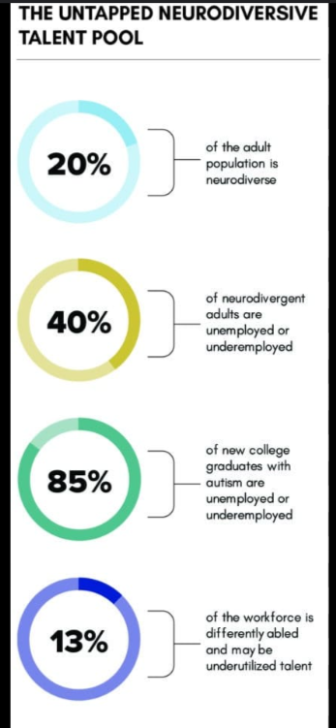

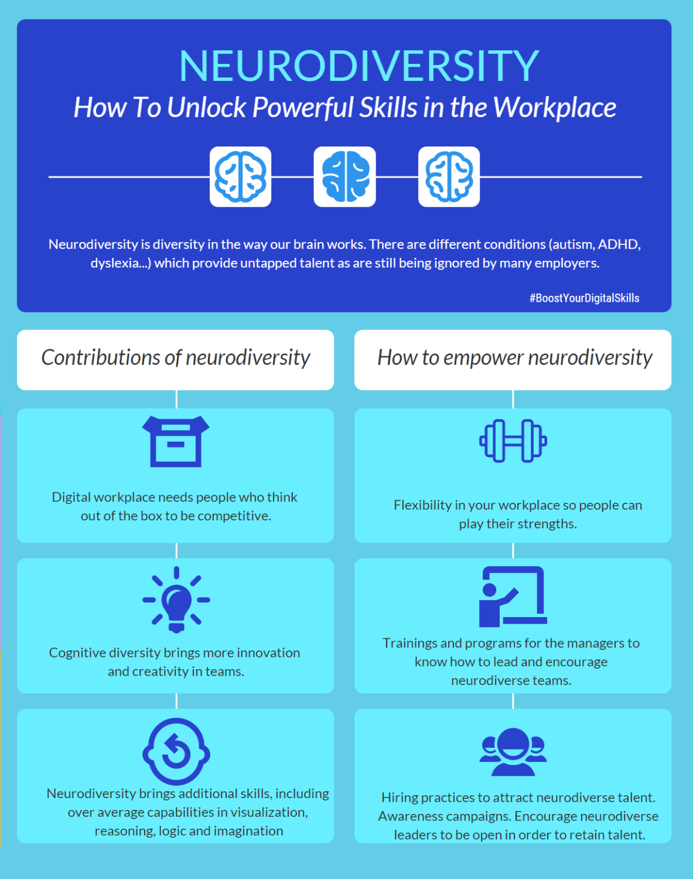

Slide 2- Target Institutions

Logos and branding- show finwell logo alongside these colleges

Show an interactive map too.

**Selection Criteria for Institutions**:

* **Support Structures**: Focus on universities with established support systems for neurodiverse students, such as dedicated resource centers, counseling, and customized learning aids.
* **Academic Excellence in Finance**: Identify institutions renowned for their robust finance programs, which are crucial for delivering the specialized content needed by students.
* **Commitment to Diversity and Inclusion**: Prioritize universities that have demonstrated a commitment to diversity and inclusion through policies, programs, or leadership initiatives.

• **University of California, Berkeley (UC Berkeley)**:

* **Finance Program**: UC Berkeley is known for its Haas School of Business, which offers top-tier finance education and is renowned for cutting-edge research and innovation in financial practices.
* **Support for Neurodiversity**: The Disabled Students' Program at UC Berkeley provides comprehensive services that could be an excellent foundation for additional neurodiverse-specific initiatives.
* **Location Benefit**: Located in the San Francisco Bay Area, it is at the heart of innovation and technology, offering ample internship and career opportunities for students.

• **New York University (NYU)**:

* **Finance Program**: NYU's Stern School of Business is a leader in global finance education and has strong ties with Wall Street, providing students with unique networking and professional opportunities.
* **Support for Neurodiversity**: NYU offers several resources through its Moses Center for Student Accessibility, which could be leveraged to tailor more specific programs for neurodiverse students.
* **Urban Setting**: The university's location in New York City allows for extensive industry connections and practical experiences that are vital for finance students.

• **Massachusetts Institute of Technology (MIT)**:

* **Finance Program**: MIT's Sloan School of Management is highly prestigious, offering rigorous finance curricula and access to a vast alumni network in the financial sector.
* **Support for Neurodiversity**: MIT is known for its supportive educational environment and its emphasis on innovation, making it a prime candidate for integrating advanced support systems for neurodiverse students.
* **Innovative Culture**: The institute's focus on technology and innovation makes it a fertile ground for developing new educational tools and methods that can benefit neurodiverse learners.

**National University of Singapore (NUS)**:

* **Finance Program**: The NUS Business School is renowned for its strong emphasis on finance education and is consistently ranked among the top business schools globally.
* **Support for Neurodiversity**: NUS provides a range of support services through its University Counselling Services, which could be enhanced to better support neurodiverse students.
* **Regional Influence**: As a leading institution in Asia, NUS's commitment to inclusivity could set a benchmark for other universities in the region.

**Indian Institute of Management Ahmedabad (IIMA)**:

* **Finance Program**: IIMA is a top choice in India for finance studies, known for its rigorous approach and extensive alumni network in the financial sector.
* **Support for Neurodiversity**: IIMA has started to take steps towards inclusivity, though there's substantial room for growth in terms of specific support for neurodiverse students.
* **Leadership in Education**: IIMA's leadership in management education in India makes it an ideal candidate for initiating and modeling inclusivity programs.

**Partnership Benefits**:

* **To the Students**: Enhanced access to tailored educational programs, internships, and mentorships that align with their unique needs and career aspirations.
* **To the Universities**: Opportunities to enhance their diversity programs, receive funding for research on neurodiversity, and increase their attractiveness to a broader applicant pool.
* **To FinWell**: Access to a diverse pool of talented individuals with unique skill sets that can drive innovation within the company, along with enhanced brand reputation as a leader in diversity and inclusion.

**Long-term Vision**:

* **Scalability**: Discuss how successful partnerships can serve as a blueprint for expansion to other educational institutions, both domestically and internationally.
* **Industry Impact**: Outline the potential for these partnerships to set new standards in the finance industry, influencing other companies to adopt similar inclusivity initiatives.
* **Community Engagement**: Highlight how engaging with universities and supporting neurodiverse students contributes to the broader community and societal goals of inclusion and diversity.

Slide 3- 3 ways –

1.Buddy Boosted internships

Peer Buddy System

• **Objective**: Establish a peer support system where neurodiverse employees are paired with colleagues who can offer guidance and support.

• **Features**: Regular check-ins, shared activities, and a structured support framework to foster a sense of belonging.

• **Outcome**: Strengthened interpersonal relationships and a supportive team dynamic, enhancing the overall work environment.

**Customized Internships**:

* **Objective**: Provide practical experience through internships that respect individual learning and working styles.
* **Features**: Flexible work hours, customized projects, and supportive supervision to accommodate different neurological needs.
* **Outcome**: Equip students with hands-on experience and increase their employability in the finance sector.
  1. FlexTech Solutions: Enhancing Productivity and Comfort

**Technology and Tools Support**:

**Objective**: Provide access to adaptive technologies and tools that assist neurodiverse employees in maximizing their potential.

**Features**: Software for visual thought organization, speech-to-text programs, or personalized task management systems.

**Outcome**: Enhance independence and efficiency, allowing neurodiverse employees to perform at their best.

**Flexible Working Arrangements**:

* **Objective**: Implement flexible work schedules and environments to accommodate different sensory and cognitive needs.
* **Features**: Options for remote work, quiet workspaces, or flexible hours to help individuals manage their energy and productivity more effectively.
* **Outcome**: Improved work-life balance and productivity, leading to higher job satisfaction and retention rates.
  1. SkillSync Sessions

**Mentorship Program**:

**Objective**: Link neurodiverse students with finance professionals at FinWell who are trained in understanding and supporting neurodiversity.

**Structure**: Offer regular one-on-one sessions, goal setting, and career planning to help students navigate their academic and early career challenges.

**Benefits**: Enhance student confidence, provide industry insights, and foster a supportive network.

**Workshop Series**:

* **Objective**: Deliver a series of workshops designed to enhance essential skills tailored to neurodiverse students.
* **Topics**:
  + **Financial Analysis Workshops**: Focus on analytical skills with tools and techniques modified to aid diverse cognitive styles.
  + **Networking Workshops**: Offer strategies for effective communication and building professional relationships, considering social interaction challenges.
  + **Professional Communication Workshops**: Teach effective workplace communication, including presentations, email etiquette, and conflict resolution.
* **Interactivity**: Include interactive elements such as role-playing, simulations, and peer feedback to reinforce learning.

Slid 4- 